|  |  |  |
| --- | --- | --- |
| **Work Integrated Learning Laboratory**  **Week 1: Web programming practice** |  | |
| Name: Atthapong Chooduang | ID: 6231302022 | Section: 1 |
| Date: | Due: Sunday Midnight | |

**Objective**

* To review basic HTML, CSS and JavaScript

**Assignment 1** Simple quiz

Create a simple quiz as shown.

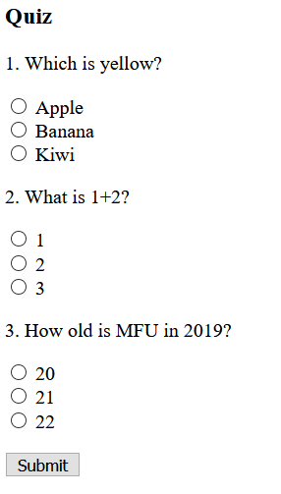

Assume that you select all correct choices and press Submit. The alert dialog shows total score.

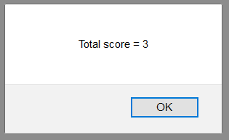

Paste your code here.

|  |
| --- |
| <!DOCTYPE html>  <html lang="en">  <head>  <meta charset="UTF-8">  <meta name="viewport" content="width=device-width, initial-scale=1.0">  <title>Quiz</title>  </head>  <body>  <h1>Quiz</h1>  <p>1. Which is yellow?</p>  <input type="radio" name="fruit" value="Apple"> Apple<br>  <input type="radio" name="fruit" value="Banana"> Banana<br>  <input type="radio" name="fruit" value="Kiwi"> Kiwi<br>  <p>2. What is 1+2?</p>  <input type="radio" name="number" value="1">1<br>  <input type="radio" name="number" value="2">2<br>  <input type="radio" name="number" value="3">3<br>  <p>3. How old is MFU in 2019?</p>  <input type="radio" name="years" value="20">20<br>  <input type="radio" name="years" value="21">21<br>  <input type="radio" name="years" value="22">22<br>  <br>  <button onclick="getRadio()">Submit</button>  <script>  function getRadio() {  var ans1 = document.querySelector("input[name = 'fruit']:checked").value;  var ans2 = document.querySelector("input[name = 'number']:checked").value;  var ans3 = document.querySelector("input[name = 'years']:checked").value;  var score = 0;  if (ans1 == "Banana") {  score++;  }  if (ans2 == "3") {  score++;  }  if (ans3 == "21") {  score++;  }  alert("Total Score= " + score);  }  </script>  </body>  </html> |

**Assignment 2** Calorie calculator

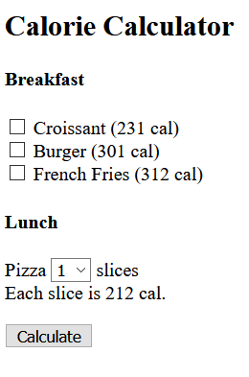

Assume that we select following choices.

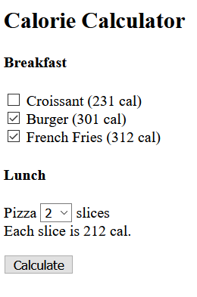 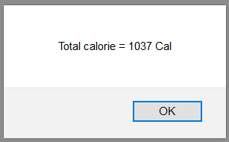

<!DOCTYPE html>

<html lang="en">

<head>

<meta charset="UTF-8">

<meta name="viewport" content="width=device-width, initial-scale=1.0">

<title>Calorie Calculator</title>

</head>

<h1>Calorie Calculator</h1>

<body>

<h3>Breakfast</h3>

<br>

<input type="checkbox" name="breakfast" value="231"> Croissant (231 cal);<br>

<input type="checkbox" name="breakfast" value="301"> Burger (301 cal);<br>

<input type="checkbox" name="breakfast" value="312"> French Fries (312 cal);<br>

<br>

<h3>Lunch</h3>

<br>

Pizza <select id="piece">

<option value="1">1</option>

<option value="2">2</option>

<option value="3">3</option>

<option value="4">4</option>

<option value="5">5</option>

</select> Slices<br>

Each slice is 212 Cal.

<br>

<button onclick="getCalculate()">Calculate</button>

<script>

function getCalculate() {

var breakfasts = document.querySelectorAll("input[name = 'breakfast']:checked");

//alert(breakfast[0].value)

var cal = 0;

for (var i = 0; i < breakfasts.length; i++) {

cal += parseInt(breakfasts[i].value);

}

//get lunch

var pieces = document.querySelector("#piece");

var y = 0;

var y = y + pieces.options[pieces.selectedIndex].value * 212;

//total

var totalCalories = cal + y;

alert("Total calories = " + totalCalories + "Cal");

}

</script>

</body>

</html>

Paste your code here.

|  |
| --- |
|  |